Customer Name: Step 1.
Countertop Project Estimation Worksheet
From The Home Depot Countertop Selling Center, record the surface(s) and group(s) that you are interested in.
Use this worksheet to complete a preliminary measurement of your solid surface and stone countertops and obtain and estimate of your
project. The price of your countertop will vary depending on the surface type, color group, edge profile and design options. Your precise cost will be calculated once a Precision Stone Design measure tech completes a template in your home and compiles a final list of project options that you have selected.
Phone:

Surface Type: Surface Type:
Color Group: Color Group:
Edge Group: Square Foot Retail Price: $ Edge Group: Square Foot Retail Price: $

Step 2. Draw a representation of your countertops in the grid below. (Refer to the reverse side of this sheet for examples of common layouts)

Step 3. Section your drawing into simple rectangles and squares, numbering them as 1, 2, 3, etc. Be sure to include any islands, bar tops, peninsulas and backsplashes, labeling them as separate sections.

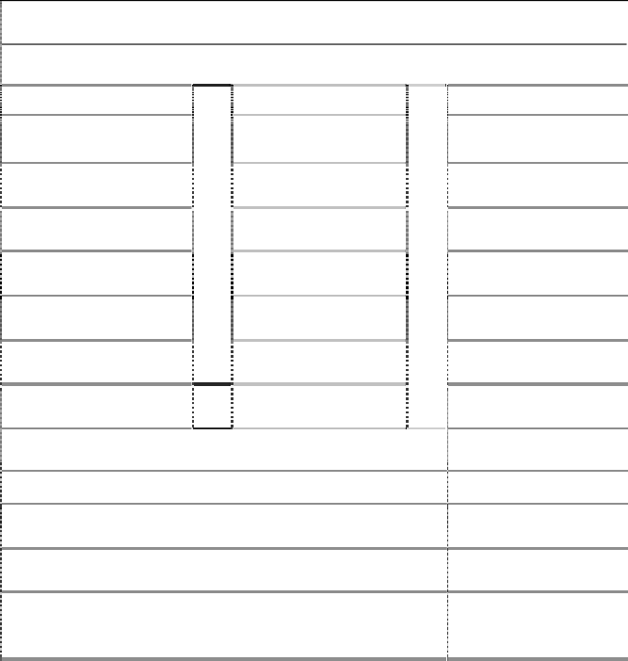
Step 4. Compute Square Footage.
Countertop Sections
Length”
1
2
x
x
x
Depth”
=
=
=
Area
3
4
5
6
7
8
x
x x x x x
=
=
=
=
=
=
Total Square Inches:
÷
= Total Square Feet:
144
x Square Foot Retail Price: $

= Estimated Basic Price: $

Measure each countertop section and record the length and depth dimensions of the sections
(in inches, rounded to the nearest inch).

- Compute the area of each section.

- Add all the sections (1-8) together to calculate the total square inches.

- Divide the total square inches by 144 to get the total square feet.

Step 5. Estimate the Countertop Price by multiplying the total square feet by the Square Foot Retail price.
Bring this worksheet to The Home Depot store to review your project with a Kitchen Designer.
HDS-5122 (06/05)

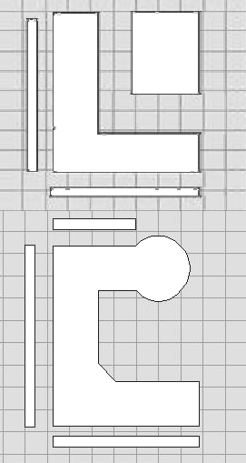
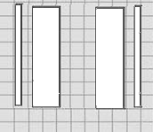
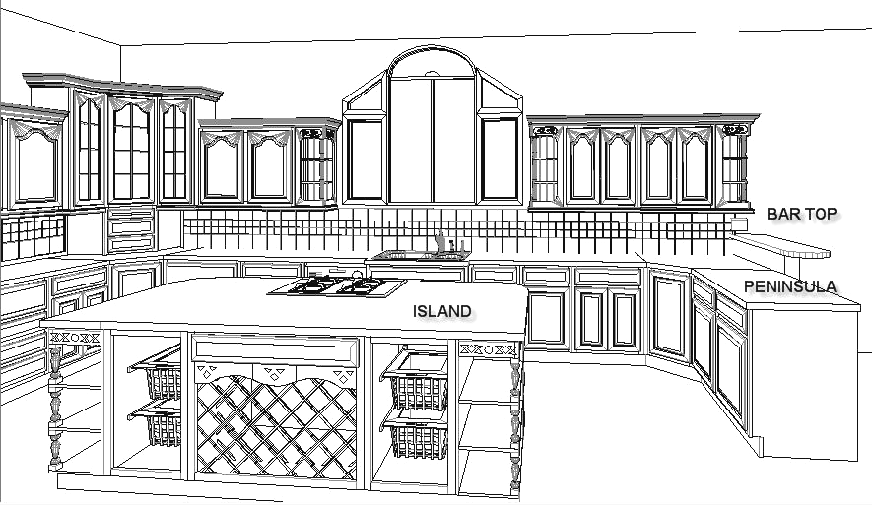
Sample Kitchen Configurations
Bar Top

Peninsula
Island
3
1
Length
(Y)
2
4
Galley
Depth
(X)
3
4 1
L-Shape

2

5
6
4
5
(X)
(Y)
7
1
(Y)
3
(X)
2
8
U-Shape

This form is for estimation purposes only. It is not an offer to sell products or services based on the information herein. The Countertop Project
Estimation Worksheet is NOT a contract.
The actual measurements for your countertop project may differ from the measurements you estimate on this form, therefore, the total estimated costs/amount of materials required for your project may be more or less than the estimate(s) listed on this form. Please note that certain materials require minimum order amounts. Please contact store for details.
Tools, products, materials, techniques, building codes requirements and local regulations change, therefore, The Home Depot assumes no liability for omissions, errors, or the outcome of any project commenced in reliance upon the measurements, costs, or drawings listed on this Countertop Project Estimation Worksheet. This form is provided strictly for estimation purposes only. If you decide to use The Home Depot’s Expert Installation, professional measurements will be taken prior to the commencement of installation.

Common Edges

¼” Round

Bevel

Eased

Bevel Stone

Ogee Stone
Installation You Can Trust.

Reliable
Precision Stone Design measures includes the following in the Basic Price of a Countertop:
x In home inspection to verify the layout, measurements, special installation requirements and template
x Radius Corners/End larger than 3/4”
x Drilling of up to 4 faucet holes
x Cutout for one sink or cooktop (unpolished top mount)

Project Options:
(Available at an Additional Cost)

x Delivery and normal installation of the countertop
x Cutout for one sink or cooktop (unpolished top mount)
x Additional faucet holes
x Outlet cutouts
x Integral bowl or undermount sinks
x Removal of existing countertops and haul away
x Plumbing & Electrical Disconnect/Reconnect
x Design and Functionality Options (e.g. drainboards, inlays, etc)
On time, courteous, respectful Service Providers working for you.

Quality Work
Expect licensed* and insured professionals who will get the job done right the first
time.

Guaranteed
Precision Stone Design will stand behind the service you receive.

Financing
We offer several convenient, attractive financing options and will find the right one for
you.***

* As required. ** Terms of guarantee may vary by service. See store for details.
*** Where available. Subject to credit approval.

